Scientific Computing

MATH6183001

**REGRESSION and INTERPOLATION**

Interpolation: constructing a curve through the points (data points are considered accurate).

Curve fitting (regression): finding a smooth curve that approximates the data in some sense (does not need to hit the data points).

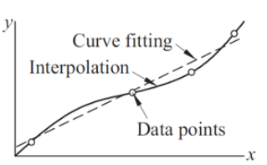

For linear interpolation: 2 points are enough.

Best curve through 5 (five) data points:

a. polynomial interpolation

b. curvilinear interpolation

Example-1:

|  |  |  |  |
| --- | --- | --- | --- |
| $$x$$ | 1.5 | 2 | 2.5 |
| $$y$$ | 4.5 | 8 | 12.5 |

Find the linear interpolation at x=2.3 based on the above data.

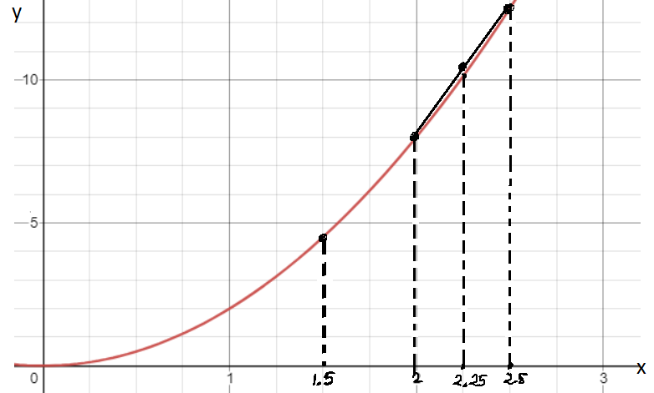

**Newton’s Polynomial Method**

Example-2:

Given:

|  |  |  |  |  |  |
| --- | --- | --- | --- | --- | --- |
| $$x$$ | -4 | 3 | -1 | 2 | -5 |
| $$y$$ | 27 | 6 | 6 | 3 | 38 |

a. Find the degree of the polynomial

b. Find the polynomial

c. Find f(2.5)

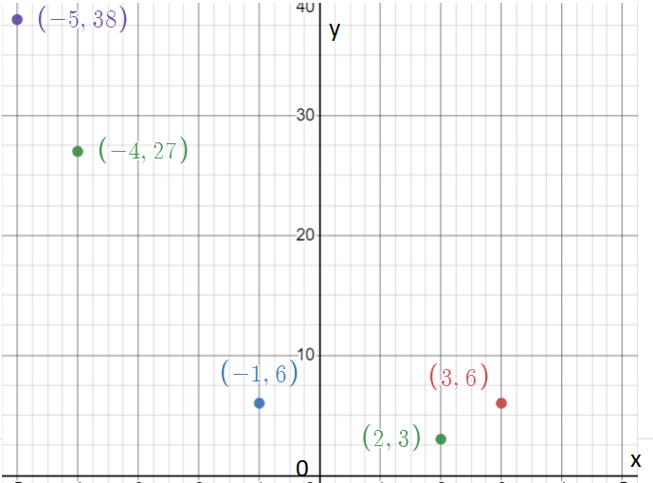

|  |  |  |  |  |  |  |
| --- | --- | --- | --- | --- | --- | --- |
| $$x_{i}$$ | $$y_{i}$$ | $$∇y_{i}$$ | $$∇^{2}y_{i}$$ | $$∇^{3}y_{i}$$ | $$∇^{4}y_{i}$$ | $$∇^{5}y_{i}$$ |
| -4 | 27 |  |  |  |  |  |
| 3 | 6 |  |  |  |  |  |
| -1 | 6 |  |  |  |  |  |
| 2 | 3 |  |  |  |  |  |
| -5 | 38 |  |  |  |  |  |

Example-3:

|  |  |  |  |  |  |
| --- | --- | --- | --- | --- | --- |
| $$x$$ | -2 | 3 | -3 | 2 | -4 |
| $$y$$ | -5 | 60 | -36 | 19 | -101 |

a. Find the degree of the polynomial

b. Find the polynomial

c. Find f(2.5)

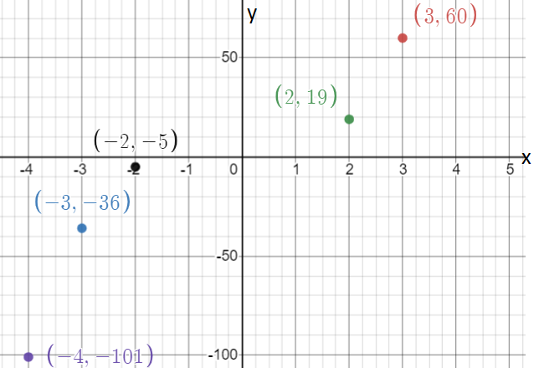

|  |  |  |  |  |  |  |
| --- | --- | --- | --- | --- | --- | --- |
| $$x_{i}$$ | $$y_{i}$$ | $$∇y_{i}$$ | $$∇^{2}y_{i}$$ | $$∇^{3}y_{i}$$ | $$∇^{4}y_{i}$$ | $$∇^{5}y_{i}$$ |
| -2 | -5 |  |  |  |  |  |
| 3 | 60 |  |  |  |  |  |
| -3 | -36 |  |  |  |  |  |
| 2 | 19 |  |  |  |  |  |
| -4 | -101 |  |  |  |  |  |

Example-4:

|  |  |  |  |  |  |
| --- | --- | --- | --- | --- | --- |
| $$x$$ | -2 | 2 | 4 | 1 | 0 |
| $$y$$ | -21 | 3 | -117 | 3 | 3 |

a. Find the degree of the polynomial

b. Find the polynomial

c. Find f(2.5)

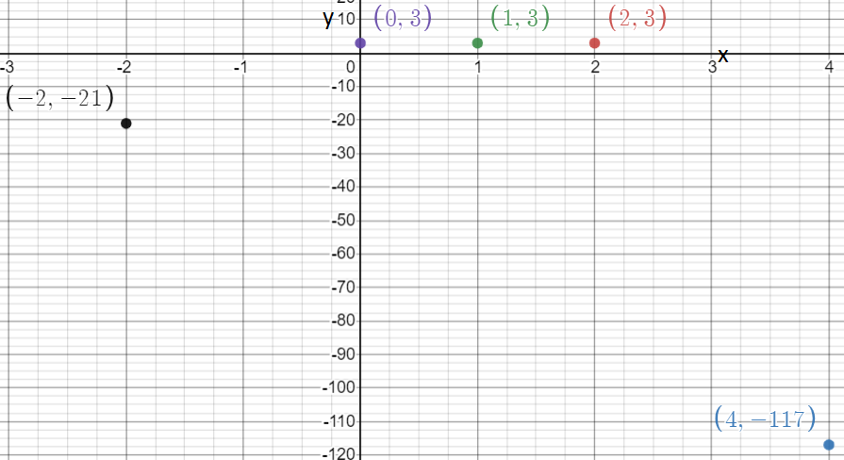

|  |  |  |  |  |  |  |
| --- | --- | --- | --- | --- | --- | --- |
| $$x_{i}$$ | $$y_{i}$$ | $$∇y_{i}$$ | $$∇^{2}y_{i}$$ | $$∇^{3}y_{i}$$ | $$∇^{4}y_{i}$$ | $$∇^{5}y_{i}$$ |
| -2 | -21 |  |  |  |  |  |
| 2 | 3 |  |  |  |  |  |
| 4 | -117 |  |  |  |  |  |
| 1 | 3 |  |  |  |  |  |
| 0 | 3 |  |  |  |  |  |

**Cubic Spline Interpolation**

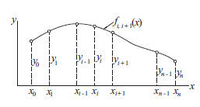

So the curve is divided into some intervals, and each interval is considered as a cubic function.

For evenly spaced interval:

If every subinterval length is h then use the following formulas.

$k_{i-1}+4k_{i}+k_{i+1}=\frac{6}{h^{2}}.(y_{i-1}-2y_{i}+y_{i+1})$

$$f\left(x\right)=\frac{{(x_{i}-x)}^{3}}{6h}.k_{i-1}+\frac{{(x-x_{i-1})}^{3}}{6h}.k_{i}+\frac{\left(x_{i}-x\right)}{h}.\left(y_{i-1}-\frac{h^{2}}{6}.k_{i-1}\right)+\frac{(x-x_{i-1})}{h}.\left(y_{i}-\frac{h^{2}}{6}.k_{i}\right)$$

The value of $i$ = 1,2,3,….n-1.

And k0 = 0, kn = 0.

Example:

|  |  |  |  |  |  |
| --- | --- | --- | --- | --- | --- |
| $$x$$ | 1 | 2 | 3 | 4 | 5 |
| $$y$$ | 0 | 1 | 0 | 1 | 0 |

Find:

a. the cubic spline interpolation function for interval 1 ≤ x ≤ 2.

b. the value of f(1.5)

c. the cubic spline interpolation function for interval 3 ≤ x ≤ 4.

d. the value of f(3.5)

Answer:

|  |  |  |  |  |  |
| --- | --- | --- | --- | --- | --- |
| knot | 0 | 1 | 2 | 3 | 4 |
| $$x$$ | 1 | 2 | 3 | 4 | 5 |
| $$y$$ | 0 | 1 | 0 | 1 | 0 |

**Linear Regression**

Linear regression line: y = a + bx.

$b=\frac{\sum{x.y}-\overline{x}.\sum{y}}{\sum{x^{2}}-n.{\overline{x}}^{2}}$ and $a=\overline{y}-b.\overline{x}$

|  |  |  |  |
| --- | --- | --- | --- |
| $$x$$ | $$y$$ | $$xy$$ | $$x^{2}$$ |
| 0 | 2.9 |  |  |
| 1 | 3.7 |  |  |
| 2 | 4.1 |  |  |
| 2.5 | 4.4 |  |  |
| 3 | 5 |  |  |
|  |  |  |  |

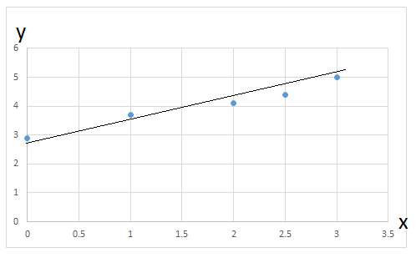

Find the regression line of the above data (use 4 d.p).

There are some cases that the numerator and denominator of $b=\frac{\sum{x.y}-\overline{x}.\sum{y}}{\sum{x^{2}}-n.{\overline{x}}^{2}}$ are closed to zero. Then the value of b will be biased.

To avoid that, we use:

$b=\frac{\sum{y.(x-\overline{x})}}{\sum{x.(x-\overline{x)}}}$ and $a=\overline{y}-b.\overline{x}$ for y = a + b.x

Find the regression line using the recent formulas (use 4 d.p).

The sum of the squares of the residual is $S=\sum{{(y-f\left(x\right))}^{2}}$

And the standard deviation is $σ=\sqrt{\frac{S}{n-2}}$

If y = a + bx, then we can find f(0), f(1), f(2), f(2.5), f(3) as in column f(x)

|  |  |  |  |  |
| --- | --- | --- | --- | --- |
| $$x$$ | $$y$$ | $$f(x)$$ | $$y-f(x)$$ | $${[y-f(x)]}^{2}$$ |
| 0 | 2.9 |  |  |  |
| 1 | 3.7 |  |  |  |
| 2 | 4.1 |  |  |  |
| 2.5 | 4.4 |  |  |  |
| 3 | 5 |  |  |  |
|  |  |  |  |  |

Find the standard deviation of the regression line (use 4 d.p).

**Exponential Regression**

Sometimes the regression is not a straight line. It is exponential.

Ex:

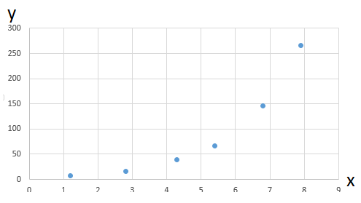

|  |  |
| --- | --- |
| $$x$$ | $$y$$ |
| 1.2 | 7.5 |
| 2.8 | 16.1 |
| 4.3 | 38.9 |
| 5.4 | 67.0 |
| 6.8 | 146.6 |
| 7.9 | 266.2 |

It can be seen that the regression curve is in the form of y = a.ebx.

The curve can be turned into straight line by putting logarithm on both sides.

|  |  |  |  |  |
| --- | --- | --- | --- | --- |
| $$x$$ | $$y$$ | $$z=ln⁡(y)$$ | $$z.(x-\overline{x})$$ | $$x.(x-\overline{x})$$ |
| 1.2 | 7.5 |  |  |  |
| 2.8 | 16.1 |  |  |  |
| 4.3 | 38.9 |  |  |  |
| 5.4 | 67.0 |  |  |  |
| 6.8 | 146.6 |  |  |  |
| 7.9 | 266.2 |  |  |  |

Find the regression curve and the standard deviation (use 4 d.p).

|  |  |  |  |  |
| --- | --- | --- | --- | --- |
| $$x$$ | $$y$$ | $$f(x)$$ | $$y-f(x)$$ | $${[y-f\left(x\right)]}^{2}$$ |
| 1.2 | 7.5 |  |  |  |
| 2.8 | 16.1 |  |  |  |
| 4.3 | 38.9 |  |  |  |
| 5.4 | 67.0 |  |  |  |
| 6.8 | 146.6 |  |  |  |
| 7.9 | 266.2 |  |  |  |